Mailtrap
# Source: AI Source: Provided by: [Data Path: Persons Table -> ID Column: 1, Name_En Column: Motasem Essam] -> From: [Chatgpt (GPT‑5 Mini)] on [1/21/2026]
Mailtrap is a cloud-based fake SMTP server for safely testing and debugging emails sent from your application — without actually delivering them to real users.

📦 What is Mailtrap?
# Source: AI Source: Provided by: [Data Path: Persons Table -> ID Column: 1, Name_En Column: Motasem Essam] -> From: [Chatgpt (GPT‑5 Mini)] on [1/21/2026]
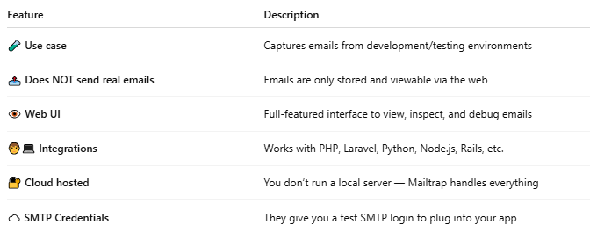

Feature | Description
🧪 Use case | Captures emails from development/testing environments
📤 Does NOT send real emails | Emails are only stored and viewable via the web
👁 Web UI | Full-featured interface to view, inspect, and debug emails
🧑‍💻 Integrations | Works with PHP, Laravel, Python, Node.js, Rails, etc.
🔐 Cloud hosted | You don’t run a local server — Mailtrap handles everything
☁️ SMTP Credentials | They give you a test SMTP login to plug into your app

✅ When to Use Mailtrap
# Source: AI Source: Provided by: [Data Path: Persons Table -> ID Column: 1, Name_En Column: Motasem Essam] -> From: [Chatgpt (GPT‑5 Mini)] on [1/21/2026]
- You want to test email features (welcome email, password reset, contact form)
- You don’t want emails to go to real users
- You want to see email headers, HTML, attachments
- You work on a team and want shared access to test emails

🛠 How It Works
# Source: AI Source: Provided by: [Data Path: Persons Table -> ID Column: 1, Name_En Column: Motasem Essam] -> From: [Chatgpt (GPT‑5 Mini)] on [1/21/2026]
1. Sign up at https://mailtrap.io
2. It gives you unique SMTP credentials like:
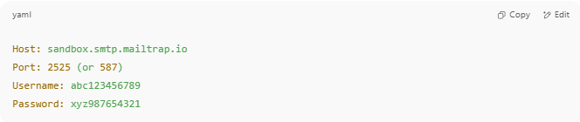
Host: sandbox.smtp.mailtrap.io
Port: 2525 (or 587)
Username: abc123456789
Password: xyz987654321

3. You use those in your PHPMailer or mailer config:
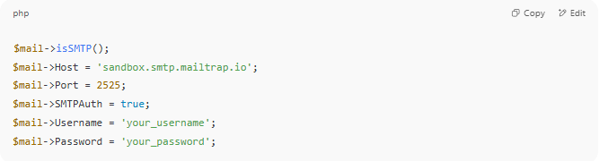
$mail->isSMTP();
$mail->Host = 'sandbox.smtp.mailtrap.io';
$mail->Port = 2525;
$mail->SMTPAuth = true;
$mail->Username = 'your_username';
$mail->Password = 'your_password';

4. Emails appear in your Mailtrap inbox online ✅

📊 Mailtrap vs MailHog vs FakeSMTP
# Source: AI Source: Provided by: [Data Path: Persons Table -> ID Column: 1, Name_En Column: Motasem Essam] -> From: [Chatgpt (GPT‑5 Mini)] on [1/21/2026]
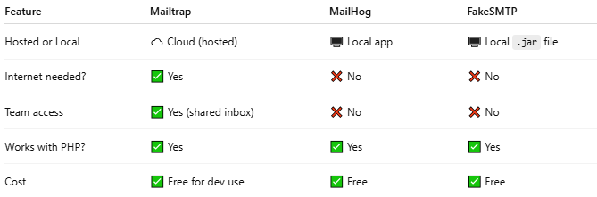

Feature | Mailtrap | MailHog | FakeSMTP
Hosted or Local | ☁️ Cloud (hosted) | 🖥️ Local app | 🖥️ Local .jar file
Internet needed? | ✅ Yes | ❌ No | ❌ No
Team access | ✅ Yes (shared inbox) | ❌ No | ❌ No
Works with PHP? | ✅ Yes | ✅ Yes | ✅ Yes
Cost | ✅ Free for dev use | ✅ Free | ✅ Free

✅ Summary
# Source: AI Source: Provided by: [Data Path: Persons Table -> ID Column: 1, Name_En Column: Motasem Essam] -> From: [Chatgpt (GPT‑5 Mini)] on [1/21/2026]
Mailtrap is a hosted email testing service.
Instead of sending real emails, it captures them in a secure test inbox so you can review and debug safely.

Sign up with Mailtrap
# Source: ScreenShots Source: Provided by: [Persons Table -> ID Column: 1, Name_En Column: Motasem Essam] -> Tool: [Lightshot Program] -> From [Site: Google Search: All: Mailtrap] on [1/21/2026]
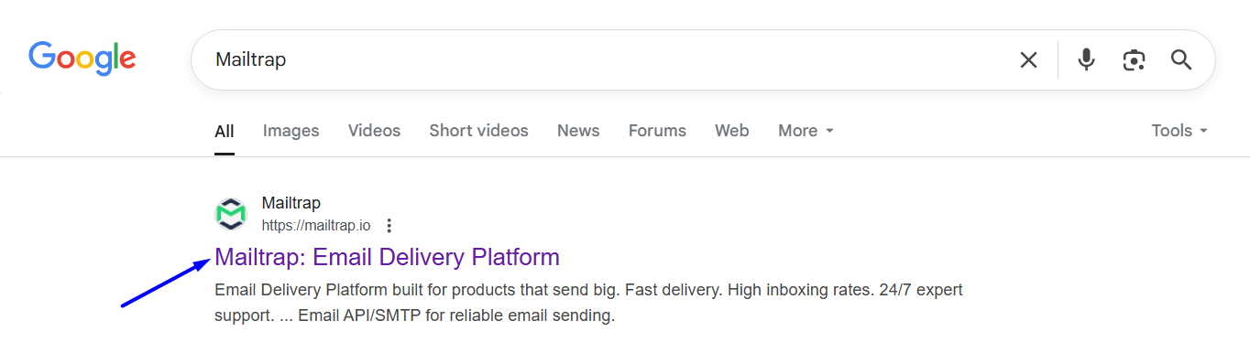


After sign up
